**Габаритные и присоединительные размеры насосов типа К**

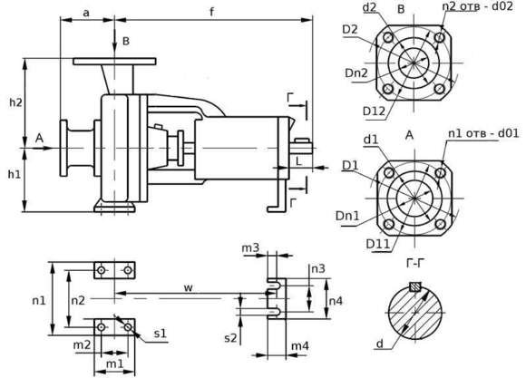

|  |  |  |  |  |  |  |  |  |  |  |  |  |  |  |  |  |  |
| --- | --- | --- | --- | --- | --- | --- | --- | --- | --- | --- | --- | --- | --- | --- | --- | --- | --- |
| Марка насоса | Габаритные и присоединительные размеры | | | | | | | | | | | | | | | | |
| a | f | h1 | h2 | m1 | m2 | m3 | m4 | n1 | n2 | n3 | n4 | w | s1 | s2 | d | L |
| К50-32-125 | 80 | 385 | 112 | 140 | 100 | 70 | 19 | 60 | 190 | 140 | 110 | 145 | 285 | 4отв-14,5 | 2отв-14,5 | 24 | 50 |
| К50-32-160 | 132 | 160 | 240 | 190 |
| К50-32-200 | 160 | 180 |
| К50-32-250 | 100 | 500 | 180 | 225 | 125 | 95 | 25 | 65 | 320 | 250 | 370 | 32 | 80 |
| К65-50-125 | 80 | 385 | 112 | 140 | 100 | 70 | 19 | 60 | 210 | 160 | 110 | 145 | 285 | 4отв-14,5 | 2отв-14,5 | 24 | 50 |
| К65-50-160 | 132 | 160 | 240 | 190 |
| К65-40-200 | 100 | 160 | 180 | 265 | 212 |
| К65-40-250 | 500 | 180 | 225 | 125 | 95 | 25 | 65 | 320 | 250 | 370 | 32 | 80 |
| К65-40-315 | 125 | 200 | 250 | 345 | 280 |
| К80-65-125 | 100 | 385 | 132 | 160 | 100 | 70 | 19 | 60 | 240 | 190 | 110 | 145 | 285 | 4отв-14,5 | 2отв-14,5 | 24 | 50 |
| К80-65-160 | 160 | 180 | 265 | 212 |
| К80-50-200 | 200 |
| К80-50-250 | 125 | 500 | 180 | 225 | 125 | 95 | 25 | 65 | 320 | 250 | 370 | 32 | 80 |
| К80-50-315 | 225 | 280 | 345 | 280 |
| К100-80-125 | 100 | 385 | 160 | 180 | 125 | 95 | 19 | 60 | 280 | 212 | 110 | 145 | 285 | 4отв-14,5 | 2отв-14,5 | 24 | 50 |
| К100-80-160 | 500 | 200 | 24 | 370 | 32 | 80 |
| К100-65-200 | 180 | 225 | 25 | 65 | 320 | 250 |
| К100-65-250 | 125 | 200 | 250 | 160 | 120 | 360 | 280 | 4отв-18,5 |
| К100-65-315 | 530 | 225 | 280 | 28 | 400 | 315 | 42 | 110 |
| К125-100-200 | 125 | 500 | 200 | 280 | 160 | 120 | 25 | 65 | 360 | 280 | 110 | 145 | 370 | 4отв-18,5 | 2отв-14,5 | 32 | 80 |
| К125-100-250 | 140 | 530 | 225 | 28 | 400 | 315 | 42 | 110 |
| К125-100-315 | 250 | 315 |
| К125-100-400 | 280 | 355 | 200 | 150 | 500 | 400 | 4отв-24 |
| К150-125-250 | 140 | 530 | 250 | 355 | 160 | 120 | 28 | 65 | 400 | 315 | 110 | 145 | 370 | 4отв-18,5 | 2отв-14,5 | 42 | 110 |
| К150-125-315 | 280 | 200 | 150 | 500 | 400 | 4отв-24 |
| К150-125-400 | 315 | 400 |
| К200-150-250 | 160 | 530 | 280 | 375 | 200 | 150 | 28 | 65 | 500 | 400 | 110 | 145 | 370 | 4отв-24 | 2отв-18,5 | 42 | 110 |
| К200-150-315 | 670 | 315 | 400 | 38 | 80 | 550 | 450 | 140 | 200 | 500 | 48 |
| К200-150-400 | 450 |

|  |  |  |  |  |  |  |  |  |  |  |
| --- | --- | --- | --- | --- | --- | --- | --- | --- | --- | --- |
| Марка насоса | Фланец на входе в насос | | | | | Фланец на выходе из насоса | | | | |
| Dn1 | D1 | D11 | d1 | n1-d01 | Dn2 | D2 | D12 | d2 | n2-d02 |
| К 50-32-125 | 50 | 165 | 125 | 102 | 4-17,5 | 32 | 140 | 100 | 78 | 4-17,5 |
| К 50-32-160 |
| К 50-32-200 |
| К 50-32-250 |
| К 65-50-125 | 65 | 185 | 145 | 122 | 50 | 165 | 125 | 102 |
| К 65-50-160 |
| К 65-40-200 | 40 | 150 | 110 | 88 |
| К 65-40-250 |
| К 65-40-315 |
| К 80-65-125 | 80 | 200 | 160 | 133 | 8-17,5 | 65 | 185 | 145 | 122 |
| К 80-65-160 |
| К 80-50-200 | 50 | 165 | 125 | 102 |
| К 80-50-250 |
| К 80-50-315 |
| К 100-80-125 | 100 | 220 | 180 | 158 | 80 | 200 | 160 | 133 | 8-17.5 |
| К 100-80-160 |
| К 100-65-200 | 65 | 185 | 145 | 122 | 4-17,5 |
| К 100-65-250 |
| К 100-65-315 |
| К 125-100-200 | 125 | 250 | 210 | 184 | 100 | 220 | 180 | 158 | 8-17,5 |
| К 125-100-250 |
| К 125-100-315 |
| К 125-100-400 |
| К 150-125-250 | 150 | 285 | 240 | 212 | 8-22 | 125 | 250 | 210 | 184 |
| К 150-125-315 |
| К 150-125-400 |
| К 200-150-250 | 200 | 340 | 295 | 368 | 12-22 | 150 | 285 | 240 | 212 | 8-22 |
| К 200-150-315 |
| К 200-150-400 |

**Габаритно-присоединительные размеры насосных агрегатов типа К.**

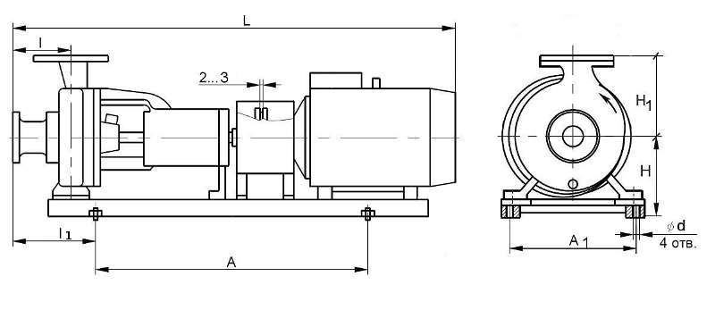

|  |  |  |  |  |  |  |  |  |
| --- | --- | --- | --- | --- | --- | --- | --- | --- |
| Тип насосного агрегата | A | A1 | d | H | H1 | L | l | l1 |
| 50-32-125 | 450 | 270 | 20 | 172 | 140 | 808 | 80 | 130 |
| 50-32-125а | 450 | 270 | 20 | 172 | 140 | 788 | 80 | 130 |
| 65-50-125 | 500 | 290 | 20 | 172 | 140 | 838 | 80 | 127 |
| 65-50-160 | 480 | 320 | 20 | 182 | 160 | 828 | 80 | 140 |
| 65-50-160а | 480 | 320 | 20 | 182 | 160 | 784 | 80 | 140 |
| 65-40-250 | 940 | 550 | 20 | 260 | 225 | 1135 | 100 | 185 |
| 80-65-160 | 480 | 350 | 20 | 220 | 180 | 913 | 100 | 165 |
| 80-65-160а | 480 | 350 | 20 | 220 | 180 | 828 | 100 | 165 |
| 80-50-200 | 600 | 380 | 20 | 230 | 200 | 1013 | 100 | 195 |
| 80-50-200а | 530 | 380 | 20 | 230 | 200 | 913 | 100 | 205 |
| 80-50-250 | 940 | 550 | 20 | 260 | 225 | 1175 | 125 | 185 |
| 100-80-160 | 680 | 380 | 20 | 230 | 200 | 1125 | 100 | 193 |
| 100-80-160а | 600 | 380 | 20 | 230 | 200 | 1035 | 100 | 193 |
| 100-65-200 | 770 | 420 | 20 | 250 | 225 | 1175 | 100 | 193 |
| 100-65-200а | 700 | 420 | 20 | 250 | 225 | 1175 | 100 | 193 |
| 100-65-250 | 700 | 490 | 20 | 270 | 250 | 1335 | 125 | 270 |
| 100-65-250а | 700 | 490 | 20 | 270 | 250 | 1235 | 125 | 270 |
| 150-125-250 | 700 | 430 | 20 | 320 | 355 | 1205 | 140 | 285 |
| 150-125-315 | 770 | 520 | 20 | 350 | 355 | 1265 | 140 | 303 |
| 200-150-250 | 700 | 520 | 20 | 430 | 375 | 1265 | 160 | 323 |
| 200-150-315 | 770 | 520 | 20 | 385 | 400 | 1540 | 160 | 405 |
| 200-150-400 | 600 | 700 | 33 | 435 | 450 | 1695 | 160 | 405 |